Share a story and enjoy these enrichment activities!

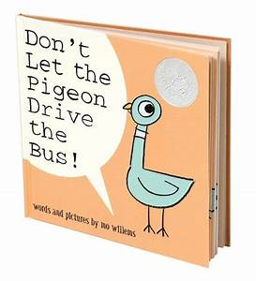Don’t Let the Pigeon Drive the Bus!
Words and Pictures by Mo Willems

You can enjoy a read along of this story here:
https://www.youtube.com/watch?time_continue=4&v=Gp16htv5dBM&feature=emb_logo

That crazy pigeon! We have to tell him “noooooo”... how can we tell him no?
We can shake our heads “no”, we can use our voice to say “no”, we can use our sign language to say “no”, some of our friends use their picture cards or devices to say “no”... practice all the ways you say “no” as you read or watch the story!

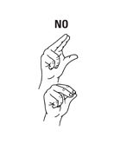

Make a pigeon handprint! Follow the instructions here: 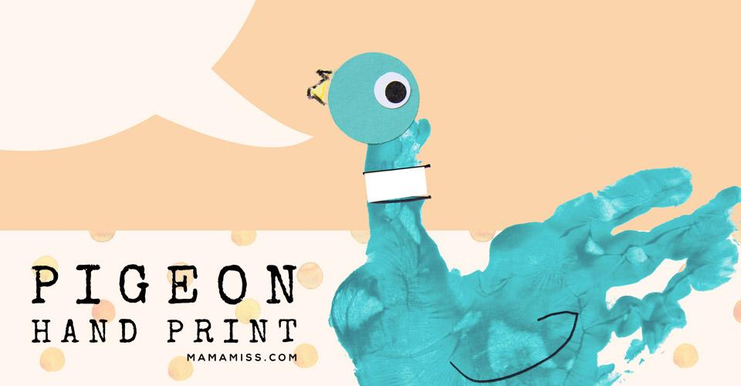
https://www.mamamiss.com/blog/2014/09/11/mo-williams-dont-let-the-pigeon-drive-the-bus/

Talk about how the pigeon tries to convince you to let him drive the bus. Why do you think he wants to drive the bus so badly? Could a pigeon really drive a bus? What would make it hard for a pigeon to drive a bus? This pigeon gets really upset because he can’t do something that he wants to do. Does that ever happen to you?

At the end of the story, does the pigeon get to drive the bus? What do you think the pigeon is thinking about driving next?

Do you know Bert from Sesame Street? 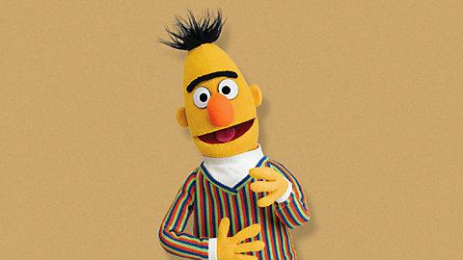
He LOVES pigeons! He even has a Pigeon Dance! Bert took some videos of pigeons and does his dance “Doin’ the Pigeon” here: https://www.youtube.com/watch?time_continue=1&v=NYHMk4skjfU&feature=emb_logo

Can you dance the Pigeon like Bert? Have fun!!!

